**ENCP 6000 Acknowledgement Form**

**Semester: Spring 2024**

**Professor: Laura Meyer**

By signing this form, I hereby acknowledge that I have accessed and read the ENCP 6000 Syllabus in its entirety. I further acknowledge that if needed, I can locate and review the syllabus on the course Canvas page.

In addition, by signing this form I agree with the following statements:

1. I fully understand the policies and expectations outlined in this syllabus.
2. I fully understand that I am a representative of the Northeastern community and I will conduct myself with professionalism.
3. I fully understand what plagiarism and academic dishonesty are as defined by the university and outlined in this syllabus. I have read the policy and watched the video.
4. I acknowledge and understand that my failure to abide by the policies outlined in this syllabus, in class, and on Canvas, as well as failure to complete assignments by due dates may have significant academic consequences for which I am solely responsible.
5. I acknowledge and understand that my failure to conduct myself professionally or uphold academic integrity may jeopardize my ability to participate in any experiential learning, which includes Internship and or/ co-op.

**Student Signature:**

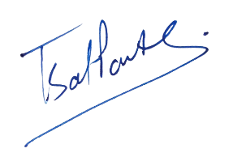

**Student Name (printed): Tapaswi Satyapanthi**

**NUID: 002857917**

**Date: 19th January 2024**